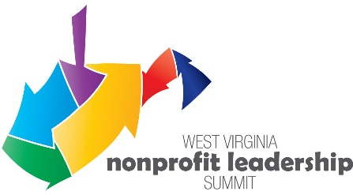

Scholarship Application
Serving Nonprofits. Strengthening West Virginia.

The West Virginia Nonprofit Association is awarding scholarships to attend the 2020 WV Virtual Nonprofit Leadership Summit: Rising to the Challenge taking place on September 22nd, 23rd, and 24th. Join nonprofit leaders from across the state to network, advance your organization’s mission, and learn from the experiences of others in the sector.

The WVNPA’s scholarship program provides an opportunity for small and medium-size nonprofits with limited budgets to advance their organizational capacity and leadership skills. Priority will be given to WVNPA Member executive directors and senior staff of organizations with operational budgets at or below $250,000. Please note that if your application request is approved and you do not attend the conference, you will be responsible for reimbursing the WVNPA for the cost of registration.

To be considered for a scholarship, please complete this application by September 16, 2020 and return by email to Tasha Anderson at tasha@wvnpa.org.

APPLICANT NAME: ___________________________________ Title: ____________________________

Organization’s Name: ___________________________________________________________________

Address: ____________________________________________ County: __________________________

City: ____________________________________ State: _____ Zip: ____________________________

Phone: __________________________ Email:_______________________________________________

NAME/TITLE OF ADDITIONAL ATTENDEE, IF APPLICABLE

__________________________________________________ ________________________________
Name Title

IS YOUR ORGANIZATION A MEMBER OF THE WVNPA? _____ YES _____ NO

SCHOLARSHIP REQUEST:

# ___ Conference Registration (limit of 3 per organization)

YOUR ORGANIZATION’S OPERATIONAL BUDGET: $___________________________
Please answer the following questions keeping your answers to one page.

1. What is your reason for requesting financial assistance?

2. What do you hope to gain from the Virtual Nonprofit Leadership Conference and how do you plan to utilize lessons learned?

