

**Strength-Based Grant Writing for Nonprofit Organizations**

**with Alice Ruhnke and Trish Hatfield**

**April 15-17, 2015**

**Dream Center, Beckley**

**Sponsored by Volunteer West Virginia**

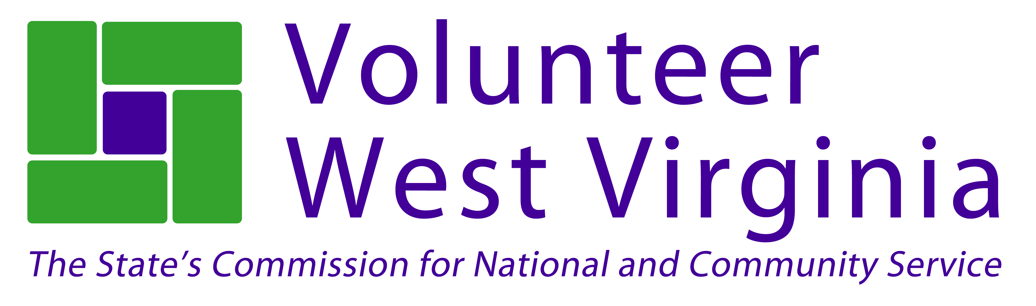

Strength-Based Grant Writing is intended to help build new capacity for nonprofit organizations. This hands-on, intensive training will help aspiring and experienced grant writers approach grant writing from a strength-based perspective. Strength-based grant writing seeks collaboration, shared understanding, and commitment to action by the organization and the larger community in identifying opportunities for change and new direction. At the end of this training, participants will not only understand all the components of a grant application, but will also have a new way of looking appreciatively at what works in their organization and community.

More than 300 people have attending this workshop since its inception. One participant recently wrote:

*I had the absolute pleasure of participating in your Strength Based Grant Writing Workshop this past October. I cannot express to you how extraordinary and worthwhile I found the entire process.*

*So far, my organization has been approved for two of the grants that I have written - there is no doubt in my mind this would not have been feasible without the tools and knowledge I gained through your workshop*.”

Come and join the growing network of nonprofit professionals approaching grant writing from this unique and energizing perspective. **Registration is limited to the first 50 people.**

We will be asking questions such as:

* What are our organization’s strengths? What can we build on? What makes us unique? How do we use our strengths to get results?
* What are our stakeholders asking for? How can we reframe challenges to be seen as exciting opportunities? What new skills do we need to move forward?
* What do we care deeply about? What do we want more of? What strategic initiatives would support our aspirations?
* What meaningful measures would indicate that we are on track to achieving our goals?

What resources are needed to implement our most vital projects?

**WVU Continuing Education Certificate in Nonprofit Management**

This training is approved for the WVU Continuing Education Certificate in Nonprofit Management. All hours completed during the three days can be counted towards the certification. For more information or to enroll in the program you can visit <http://socialwork.wvu.edu/continuing-education/continuing-education-certificate-in-nonprofit-management> or contact Jacki Englehardt at [304-293-3280](mailto:304-293-3280), [jacki.englehardt@mail.wvu.edu](mailto:jacki.englehardt@mail.wvu.edu)

**Training Times**

April 15: 10am-5:00pm

April 16: 9am-5:00pm

April 17: 9am-12:30pm

**Cost**

Registration is $199 per person. This fee covers all materials, lunch on Wednesday and Thursday and breaks each day. Members of the ***West Virginia Nonprofit Association*** are eligible to attend at a discounted rate of $149. Please make checks payable to ***Volunteer West Virginia.*** We would be happy to send an invoice if that is more convenient for you or your organization. We are unable to accept credit card payments.

**Lodging**

A block of rooms has been reserved at the Fairfield Inn, 125 Hylton Lane, Beckley, WV 25801. If you would like to be included on the room list and have the lodging cost added to your invoice, please indicate this on your registration form. If you prefer to make your own reservation, you can call 304-252-8661 and ask for the Volunteer West Virginia room block.

**Instructors**

**Alice Ruhnke**, the founder and chief operating officer of The Grant Advantage, works with nonprofit organizations to help them increase their organizational capacity and secure funding.

[www.thegrantadvantage.net](http://www.thegrantadvantage.net)

**Trish Hatfield**, president of CharacterEthics, helps people build skills, co-create solutions, and explore tough issues that lead to better performance as individuals and communities.

[www.characterethics.com](http://www.characterethics.com)

**Questions?**

Please contact Moya Doneghy at 304-558-0111 or [moya.doneghy@wv.gov](mailto:moya.doneghy@wv.gov).