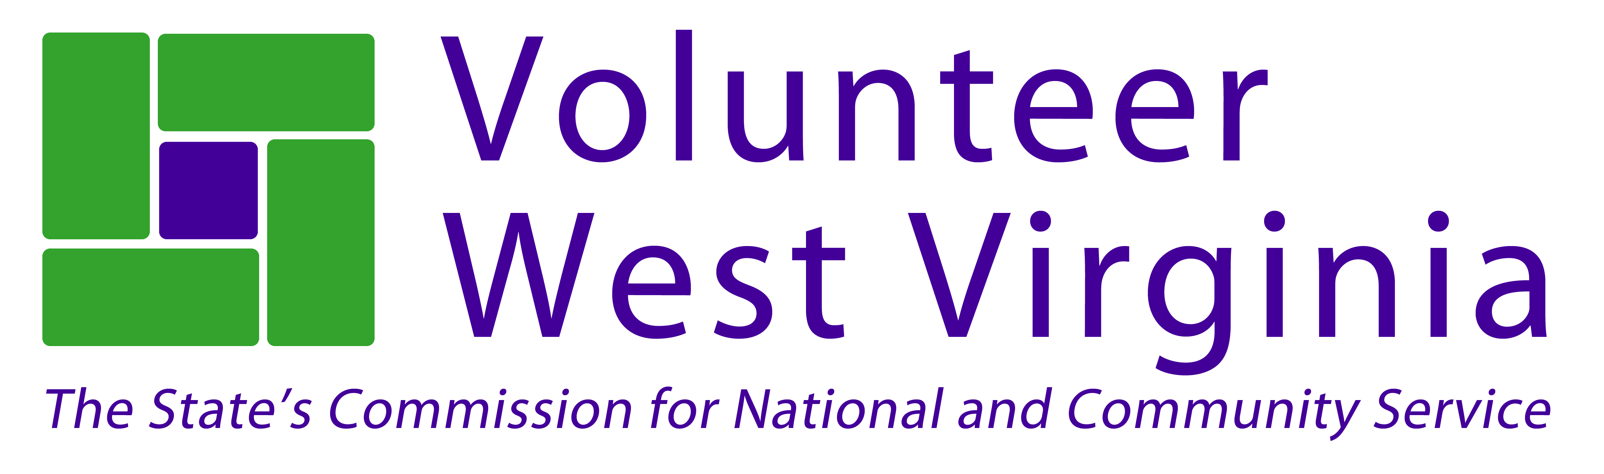

**Strength-Based Grant Writing**

**April 15-17, 2015**

Beckley Dream Center

224 Pinewood Drive, Beckley, WV 25801

**Complete and return by April 8, 2015**

Name: _____________________________________________________________________________________________

Organization: _____________________________________________________________________________________

Address: _____________________________________________________________________________________

City: _________________________________ State: _________ Zip: ________________________________

Phone: ______________________________ County: ____________________________________________________

Email: ______________________________________________________________________________________________

Registration @ $199  West Virginia Nonprofit Association (W member VNPA) @ $149

Lodging at the Fairfield Inn (125 Hylton Lane, Beckley, WV 25801) is available for $83 per night on our room list.

Please add me to the room list at the Fairfield Inn:  April 14  April 15  April 16

Amount Enclosed: _______________________ Please Invoice:

Special Requests: _______________________________________________________________

**Training times:**

April 15: 10am-5:00pm

April 16: 9am-5:00pm

April 17: 9am-12:30pm

**Send registration form to:**

Volunteer West Virginia

Grant Writing Training

710 Central Avenue

Charleston, WV, 25302

Questions? Call Moya Doneghy at 304-558-0111 – [Moya.Doneghy@wv.gov](mailto:Moya.Doneghy@wv.gov)