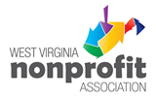

**WVNPA ‘Ask an Expert’**

Be a topic expert and provide one-on-one phone consultation to nonprofit organizations during a one-hour period. ‘Ask an Expert’ is a new member benefit that will be offered every other month beginning in March 2018.

Name:

Company:

Address:

City/State/Zip:

Phone:

Email:

1. **My area of Expertise:**
2. **My preferred ‘Ask an Expert/ month:**

March _____ May _____ August _____ October _____ December _____

1. **What is your related training and presentation experience?**
2. **Contact information of 3 References:**